SQL DDL Assignment – Employee Database Management System

Project Overview
This project demonstrates the implementation of Data Definition Language (DDL) commands in MySQL by designing and managing an Employee Database Management System. The assignment focuses on creating a relational database, defining table structures, enforcing data integrity through constraints, modifying database objects, and performing database maintenance operations.

Objectives
- Create and manage a relational database using MySQL.
- Design tables with appropriate data types and constraints.
- Establish relationships using Primary Keys and Foreign Keys.
- Modify existing table structures using ALTER TABLE.
- Perform table renaming, truncation, and deletion operations.
- Understand the complete lifecycle of database schema management.

Technologies Used
- MySQL 8.x
- MySQL Workbench
- SQL (DDL Commands)

Database Schema

Database
Employee_DB

Tables Created

1. Department_Table
Stores department information.
Column | Data Type | Constraint
Department_ID | INT | Primary Key
Department_Name | VARCHAR(50) | NOT NULL, UNIQUE

2. Location_Table
Stores employee work locations.
Column | Data Type | Constraint
Location_ID | INT | AUTO_INCREMENT, Primary Key
Location_Name | VARCHAR(50) | NOT NULL, UNIQUE

3. Employee_Table
Stores employee information.
Column | Data Type | Constraint
Emp_ID | INT | Primary Key
Emp_Name | VARCHAR(50) | NOT NULL
Gender | VARCHAR(1) | CHECK ('M','F')
Age | INT | CHECK (Age >= 18)
Hire_Date | TIMESTAMP | DEFAULT CURRENT_TIMESTAMP
Designation | VARCHAR(20)
Salary | DECIMAL(10,2)
Department_ID | INT | Foreign Key
Location_ID | INT | Foreign Key

Constraints Implemented

Primary Keys
- Department_ID
- Location_ID
- Emp_ID

Foreign Keys
- Department_ID → Department_Table(Department_ID)
- Location_ID → Location_Table(Location_ID)

Unique Constraints
- Department_Name
- Location_Name

NOT NULL Constraints
- Department_Name
- Location_Name
- Emp_Name

CHECK Constraints
- Gender must contain only M or F
- Employee age must be 18 years or above

Default Constraint
- Hire_Date automatically stores the current system timestamp.

Schema Modification (ALTER TABLE)
The following schema modifications were performed:
- Added Email_Address column.
- Modified Designation column from VARCHAR(20) to VARCHAR(100).
- Dropped the Age column.
- Renamed Hire_Date to Date_of_Joining.

Table Renaming
The following tables were renamed:
Old Name | New Name
Department_Table | Departments_Info
Location_Table | Locations

Database Maintenance Operations
The assignment also demonstrates common maintenance commands:
- TRUNCATE TABLE Employee_Table
- DROP TABLE Employee_Table
- DROP DATABASE Employee_DB
These commands illustrate how to remove data, delete tables, and completely remove a database when it is no longer required.

SQL Concepts Covered
- CREATE DATABASE
- USE DATABASE
- CREATE TABLE
- PRIMARY KEY
- FOREIGN KEY
- AUTO_INCREMENT
- NOT NULL
- UNIQUE
- CHECK
- DEFAULT
- ALTER TABLE
- ADD COLUMN
- MODIFY COLUMN
- DROP COLUMN
- CHANGE COLUMN
- RENAME TABLE
- TRUNCATE TABLE
- DROP TABLE
- DROP DATABASE

Learning Outcomes
By completing this assignment, the following SQL concepts were reinforced:
- Designing relational database schemas.
- Applying data integrity constraints.
- Creating relationships between multiple tables.
- Managing database structures using DDL commands.
- Modifying table definitions without affecting database integrity.
- Understanding schema evolution and database maintenance.
- Implementing industry-standard database design practices.

Mysql Queries used:
Create database IF NOT EXISTS Employee_DB;
use Employee_DB;
Create table Department_Table
(
Department_id INT primary key,
Department_Name varchar(50) Not null Unique
);
Create table Location_Table
(
Location_id INT auto_increment primary key,
Location_Name Varchar(50) Not Null Unique
);
Create table Employee_Table
(
Emp_ID INT Primary Key,
Emp_Name Varchar(50) NOT null,
Gender Varchar(1) CHECK (Gender in ('M','F')),
Age INT check (Age>=18),
Hire_Date timestamp default current_timestamp,
Designation Varchar(20),
Salary Decimal(10,2),
Department_id INT,
Location_id INT,
Foreign Key (Department_id) references Department_Table(Department_id),
foreign key(Location_id) references Location_Table(Location_id)
);
Alter table Employee_Table
add Email_Adress Varchar(100);
Alter table Employee_Table
modify Designation Varchar(100);
Alter table Employee_Table
Drop column age;
Alter table Employee_Table
change Hire_Date Date_of_Joining date ;
rename table Department_Table to Departments_Info;
rename table Location_Table to Locations;
truncate table Employee_Table;
Drop table Emplyee_Table;
Drop database IF exists Employee_DB;

Screenshots:

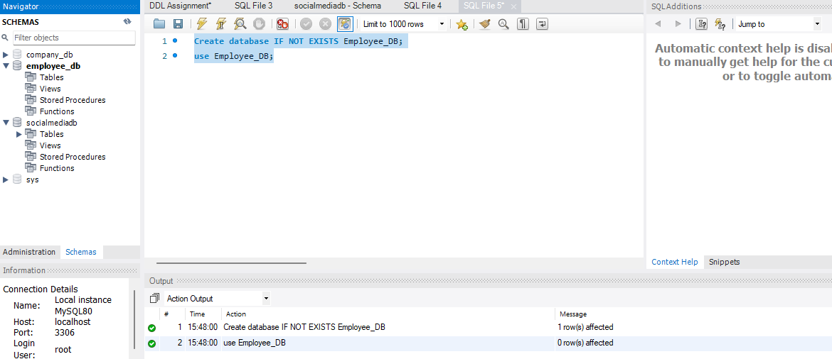
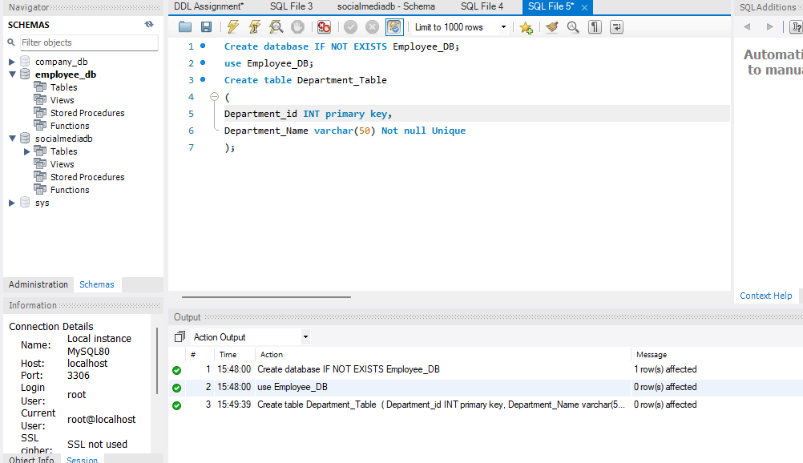
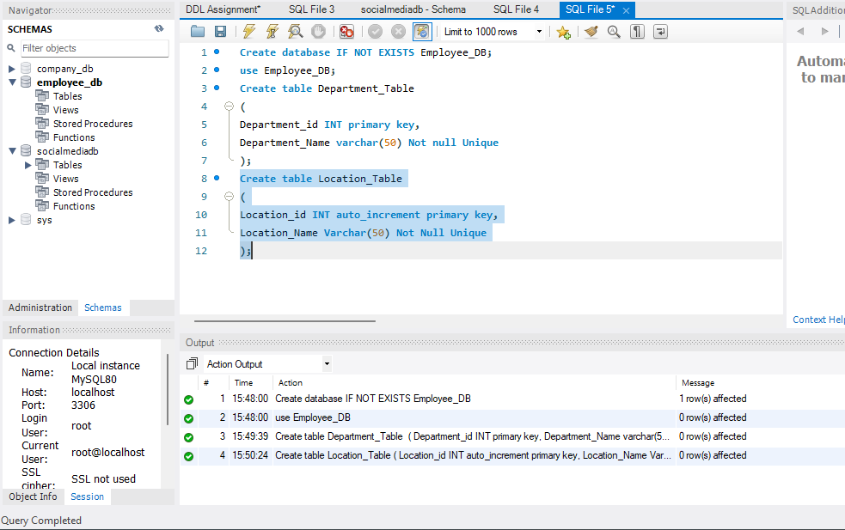
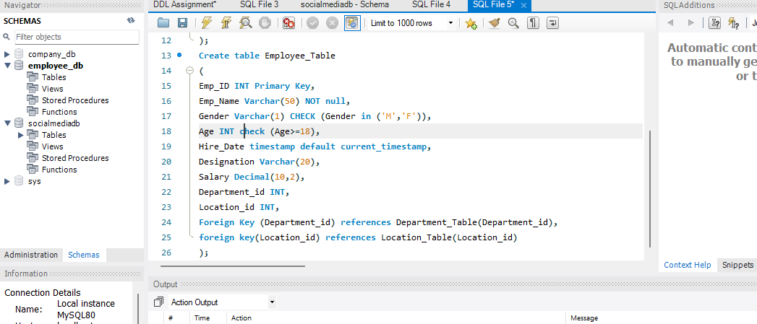
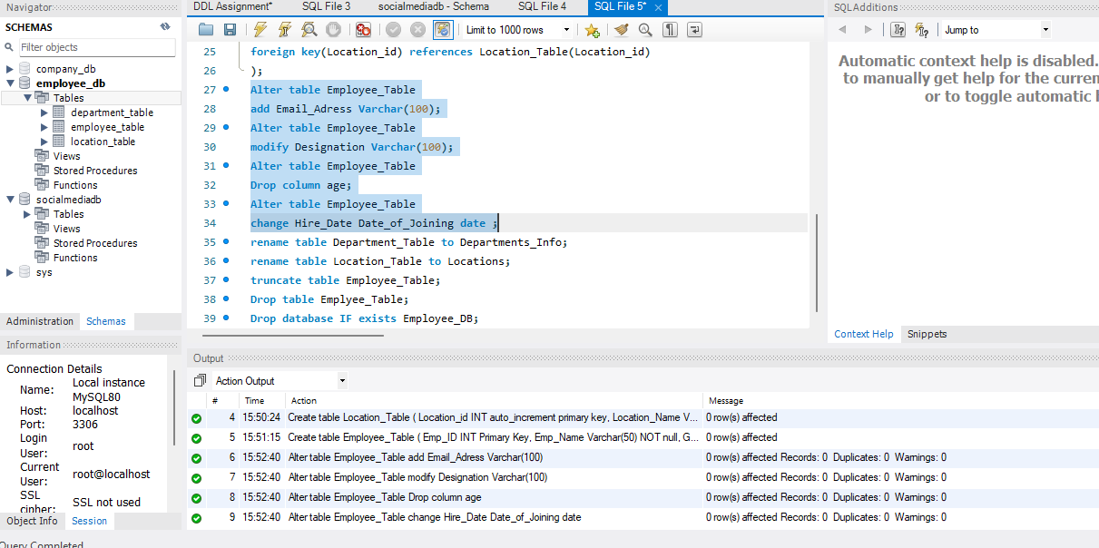

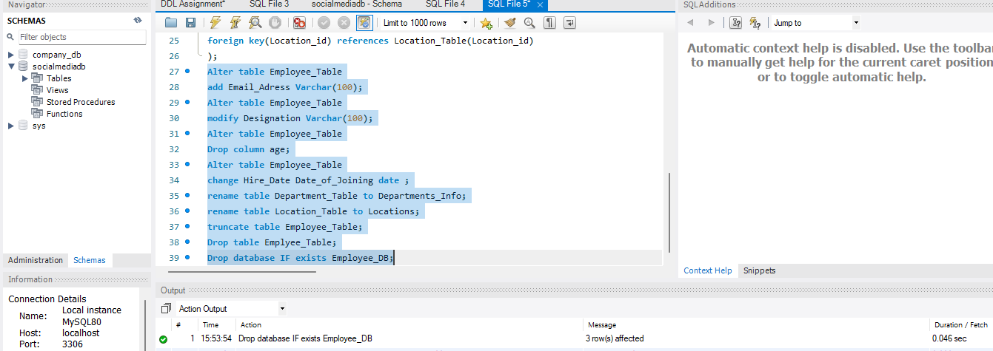

Conclusion
This project provided practical experience with SQL Data Definition Language (DDL) by designing and managing a relational Employee Database Management System. It demonstrates proficiency in database creation, constraint implementation, relationship management, schema modification, and database administration using MySQL, establishing a solid foundation for advanced SQL, database design, and data engineering concepts.

